Chapter 1 — Prediction Without Understanding
Physics is often described as the most successful intellectual enterprise in human history. Its equations predict eclipses centuries in advance, enable global communications, unlock nuclear energy, and describe matter down to scales smaller than atoms (Feynman, 1965).
By almost any practical measure, it works. And yet something fundamental is missing. Modern physics predicts outcomes with extraordinary accuracy, but it struggles to explain why this particular outcome occurs. It tells us what distributions to expect, what averages will emerge, what probabilities govern ensembles—but when asked why this particle landed here, or why this measurement produced that result, it falls silent.
The answer is usually some version of: because that is what the probabilities allow (Born, 1926). This does not constitute a physical mechanism. It is a statistical description. Over time, this gap has been normalised. Students are taught early that asking deeper questions is naïve, that the universe is “inherently random,” and that the role of physics is not to explain reality but to predict observations (Bohr, 1928).
The discomfort is reframed as sophistication. The missing mechanism becomes a feature. But prediction without explanation is not a completed science. It is an unfinished one.

The Success That Conceals the Absence
The strength of physics has become its shield. Because the equations work, the lack of mechanism can be treated as irrelevant. Because technology advances, conceptual discontinuity can be ignored. Because the predictions land, the explanation can be postponed indefinitely.
But “works” can mean two different things. A theory can work as an instrument—producing correct numbers—without working as an account of reality. It can guide action while remaining silent about what is actually happening. This difference matters because the silence is not distributed evenly. It concentrates at the same place every time: the moment an outcome becomes fixed.
This structural discontinuity is illustrated schematically in Figure 1.1.
Figure 1.1 — Prediction Without Realisation
State-based physical theories evolve deterministically until a concrete outcome is required. At that point, the theory ceases to describe physical process and substitutes an external rule—collapse, probability, or interpretation (von Neumann, 1932). This structural discontinuity is illustrated schematically in Figure 1.1, highlighting the transition from deterministic evolution to non-mechanistic outcome selection.
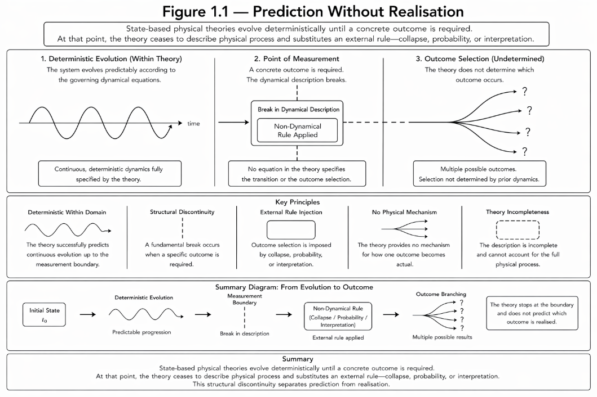

The Measurement Problem Is Not a Detail
At the heart of modern physics lies a fracture that has been defended through habit rather than repaired through understanding. In quantum mechanics, a system evolves smoothly according to precise equations—until it is measured.
At that moment, the smooth description is abandoned and replaced by a rule that is not derived, not explained, and not physical: collapse (Bohr, 1928; Einstein, 1935). Collapse is said to be instantaneous. It is said to be random. It is said to occur when measurement happens, yet “measurement” has no definition inside the mathematics itself. Collapse does not arise from the formalism. It is inserted where the formalism must connect to experience (von Neumann, 1932).
This alone should give us pause. Few areas of physics accept such a direct discontinuity between governing law and realised outcome. We do not say planets obey equations until someone looks through a telescope. We do not say electromagnetic waves propagate until a detector decides which photon arrived. Yet in quantum mechanics, we accept a theory that is complete in evolution and incomplete in realisation.
This is not a new discomfort. Einstein’s objection was never that the equations failed. It was that a physical theory should not end exactly where an outcome becomes real — that a complete description of reality must account for the individual event, not only the statistical ensemble (Einstein, 1935).
Interpretations manage the fracture, but they do not remove it. Copenhagen was historically pragmatic: a way to keep the machine running when no mechanism was available (Bohr, 1928). Many-worlds removes collapse by multiplying outcomes, not by explaining why any one is experienced as fixed (Everett, 1957). Decoherence explains why interference becomes inaccessible, while carefully declining to explain why a single result is realised (Zurek, 2003).
The fracture remains because the theory lacks a physical account of outcome selection—of how one concrete event becomes fixed from many allowed ones.

Probability Is Standing In for Process
Probability entered physics as a tool—a way to handle ignorance about complex systems. In statistical mechanics, probabilities reflect incomplete access to microscopic states (Gibbs, 1902).
In quantum mechanics, probability is elevated to a principle about reality itself, typically via the Born rule and the measurement postulates (Born, 1926). The universe, we are told, does not determine outcomes until they are observed. This is an extraordinary claim, and it sits uneasily beside the mathematics.
Between measurements, the Schrödinger equation evolves deterministically and preserves probability via unitary time evolution (Schrödinger, 1926). It does not roll dice. Randomness appears only when we demand a realised outcome, through the added measurement axioms and the projection/collapse rule (von Neumann, 1932).
Probability is not embedded in the dynamics in the same way the unitary evolution is. It is invoked at the point where the dynamics end. This substitution is shown in Figure 1.2.
Figure 1.2 — Probability as a Stand-In for Missing Mechanism
Deterministic evolution governs physical systems until an outcome must be realised. At that boundary, physical process is replaced by probabilistic description rather than completed by mechanism.

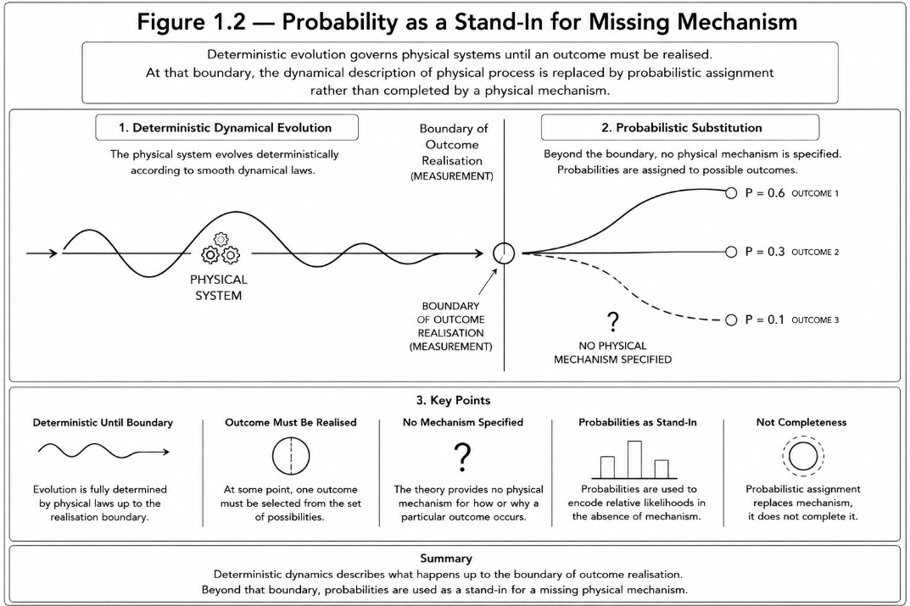

When a theory cannot describe how a process completes, it resorts to statistics. When it cannot say why one outcome occurs, it speaks of likelihoods. This is not a failure of mathematics. It is a signal that the ontology—the account of what is physically happening—has not been completed (Bell, 1964).

Why This Matters Beyond Philosophy
It is tempting to treat these concerns as philosophical. After all, the equations work. Predictions are confirmed. Technology advances. Why insist on deeper explanation?
Because the limits are already visible. Prediction breaks down in complex systems. Long-range forecasts fail catastrophically. Models must be reset, recalibrated, or abandoned. Engineers know this in practice: prediction works while systems remain within narrow tolerance bounds. Outside those bounds, behaviour becomes unstable—not merely unpredictable, but structurally opaque.
We see this in weather, in networks, in biological systems, and even in carefully controlled experiments (Lorenz, 1963). Something accumulates. Something drifts. Then the model fails—not gradually, but abruptly.
Current theory often files this under chaos, noise, or randomness. But chaos is not “uncaused”: it is deterministic dynamics with sensitive dependence, which sets principled limits on practical predictability (Lorenz, 1963). These are labels, not mechanisms. They name the boundary where explanation stops.
If physics is to extend beyond idealised systems—if it is to address real, evolving, interacting reality—it must account not only for smooth evolution, but for how outcomes become fixed, why resolution is irreversible, and where prediction must fail in principle.
Determinism, if it is true, does not guarantee practical predictability. It asserts only that realised outcomes are constrained by physical structure, not chosen by chance (Einstein, 1935). This distinction matters, because it separates “unknown” from “uncaused.”

The Hidden Assumption
Underlying almost all modern theory is an assumption so common it is rarely examined: that reality is best described as states evolving in time. Those states may be wavefunctions, fields, metrics, or configurations, but the structure is the same.
At each moment, the system is in a state. Laws tell us how the state changes. Measurement somehow selects one.
What if this is the wrong starting point? What if the universe is not fundamentally a sequence of states but a continuous process of phase evolution, where outcomes emerge when differences accumulate beyond tolerance? What if “measurement” is not an epistemic act, but a physical event: an irreversible locking triggered when accumulated phase differences exceed a finite coherence threshold?
Decoherence theory has shown that classical behaviour emerges from quantum systems through environmental entanglement (Zurek, 2003), but stops short of explaining why a single outcome is realised. Measurement, on this view, is a physical interaction that exceeds local coherence capacity—not a special act of observation.
If that is true, collapse is no longer a mystery. Probability is no longer fundamental. And prediction has a principled boundary.

What This Book Will Do
Phase Differential Theory proposes that phase difference, not state, is the primitive quantity of reality. It replaces collapse with a physical mechanism—phase-snap—and reframes energy, time, measurement, and causality as emergent consequences of phase dynamics.
Phase Differential Theory does not reject quantum mechanics nor revive classical physics. It supplies the missing physical mechanism early quantum theory set aside, restoring determinism without sacrificing empirical success. Quantum mechanics is recovered as a linear approximation. General relativity is reinterpreted as a macroscopic phase-gradient description. Thermodynamics is grounded in coherence loss rather than abstract disorder (Gibbs, 1902).
Prediction is understood as possible only before irreversible phase locking occurs. Most importantly, the framework aims to explain why one outcome happens, not merely how often outcomes occur in the long run.
The chapters that follow build this carefully, step by step—starting not with exotic claims, but with the minimum change required to make physics internally coherent again.

Scope of Description
It is important to be precise about what is being replaced and what is not.
The existing formalism of quantum mechanics describes the evolution of systems prior to outcome realisation with extraordinary accuracy. That role is retained. Phase Differential Theory does not alter the predictive structure governing pre-measurement evolution. It addresses a different domain: the physical process by which one outcome becomes fixed.
The boundary between these domains is exactly where current theory introduces collapse. Standard physics describes how possibilities evolve. Phase Differential Theory describes how one possibility becomes real.
The two are not in conflict. They apply to different stages of the same process.

Bridge to Chapter 2
The discontinuity in modern physics is not distributed evenly. It concentrates at the moment an outcome becomes fixed. To make progress, we must examine the measurement problem directly and treat it as physics, not philosophy.

References (Chapter 1)
Bell, J. S. (1964). On the Einstein–Podolsky–Rosen paradox. Physics, 1, 195–200.
Bohr, N. (1928). The Quantum Postulate and the Recent Development of Atomic Theory. Nature, 121, 580–590.
Born, M. (1926). Zur Quantenmechanik der Stoßvorgänge. Zeitschrift für Physik, 37, 863–867.
Einstein, A. (1935). Can Quantum-Mechanical Description of Physical Reality Be Considered Complete? Physical Review, 47, 777–780.
Everett, H. (1957). “Relative State” Formulation of Quantum Mechanics. Reviews of Modern Physics, 29, 454–462.
Feynman, R. P. (1965). The Character of Physical Law. MIT Press.
Gibbs, J. W. (1902). Elementary Principles in Statistical Mechanics. Yale University Press.
Lorenz, E. N. (1963). Deterministic Nonperiodic Flow. Journal of the Atmospheric Sciences, 20, 130–141.
Schrödinger, E. (1926). Quantisierung als Eigenwertproblem. Annalen der Physik, 79, 361–376.
von Neumann, J. (1932). Mathematische Grundlagen der Quantenmechanik. Springer.
Zurek, W. H. (2003). Decoherence, einselection, and the quantum origins of the classical. Reviews of Modern Physics, 75, 715–775

